1. Search PowerBI desktop in Google and click on the download page from MS

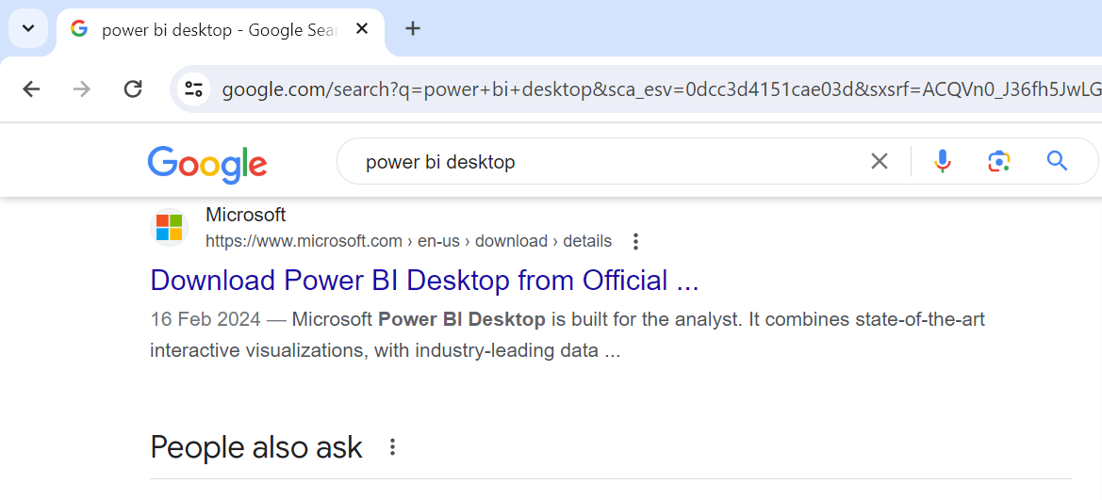

1. Click on Download

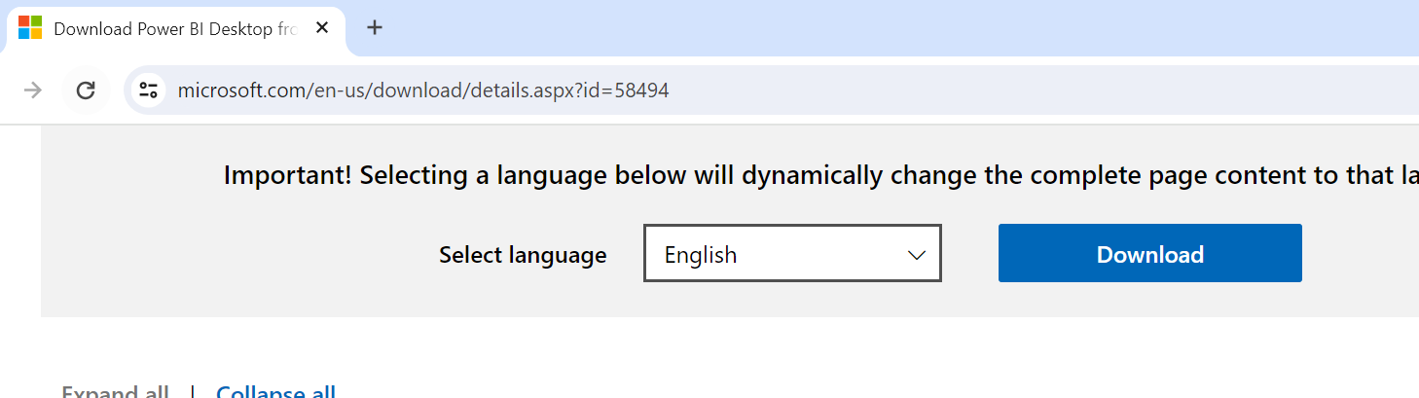

1. Choose the second option if you have 64 bit system

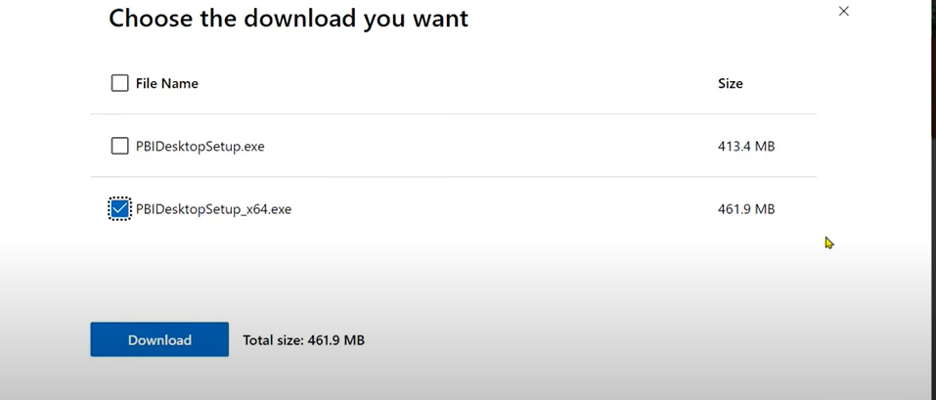

1. Once Downloaded, doble click on the download

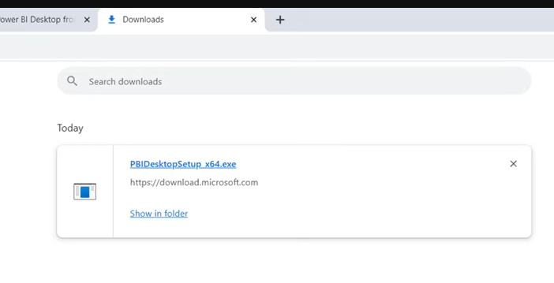

1. Select Language and click on Next

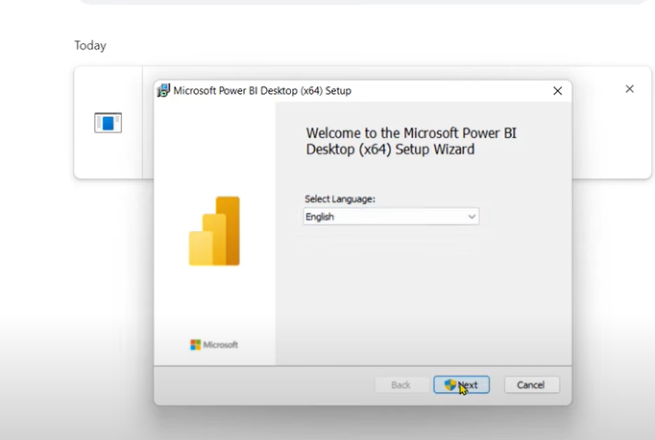

1. Click on acknowledgement and then Next

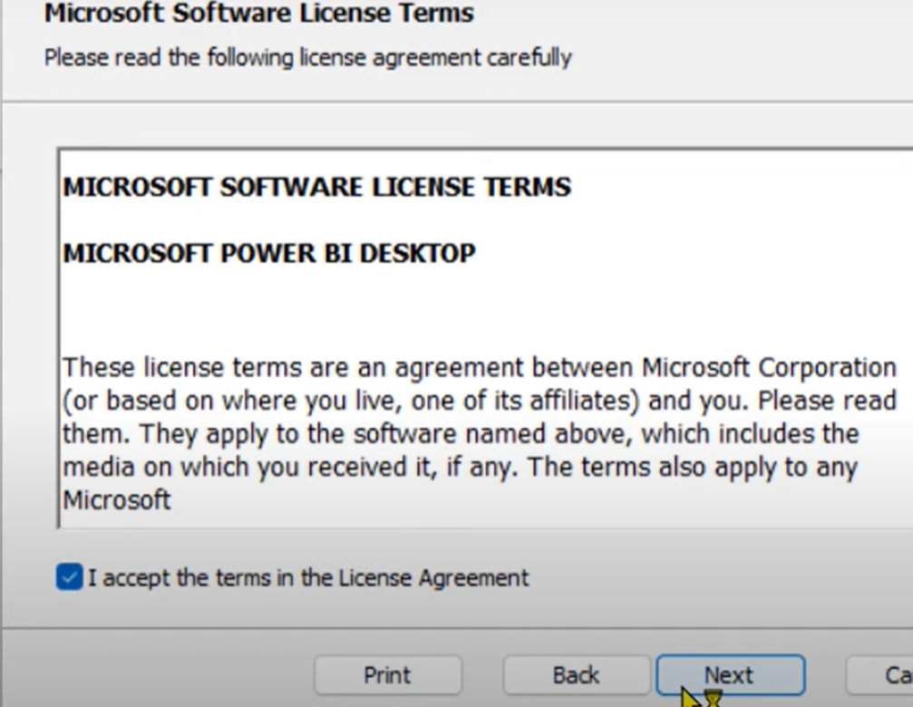

1. Select the destination folder and click on next

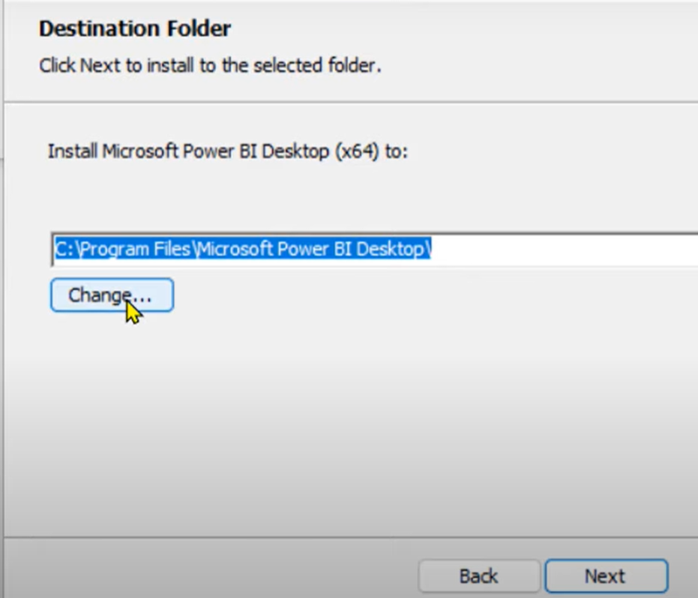

1. Select if want and icon in desktop and click on Install

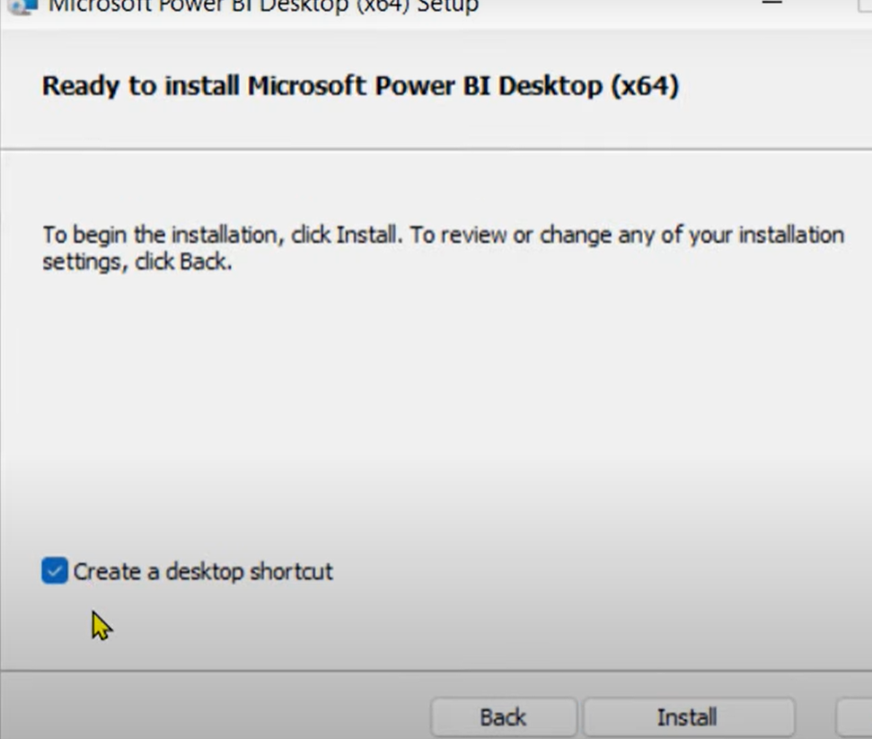

1. Once installation is complete and click on finish

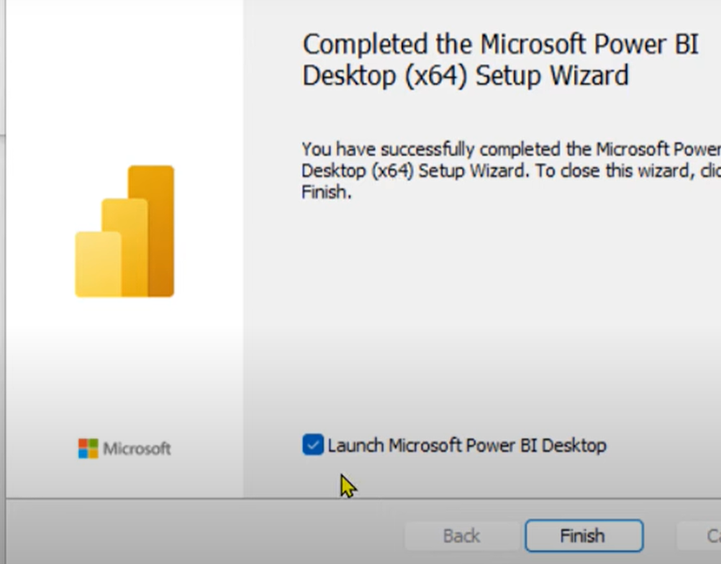

1. Click on Get started

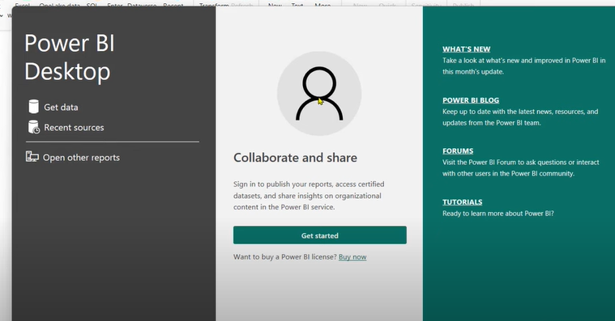

1. You are all set

